**Quality Management Plan**

**Project Details:**

|  |  |
| --- | --- |
| Project Name |  |
| Project Code |  |
| Client |  |

|  |  |  |  |  |  |
| --- | --- | --- | --- | --- | --- |
| **Version** | **Nature of changes** | **Details of amendment** | **Author** | **Approval** | **Date** |
| 1.0 | Original Release | N/A |  |  |  |
|  |  |  |  |  |  |
|  |  |  |  |  |  |
|  |  |  |  |  |  |
|  |  |  |  |  |  |
|  |  |  |  |  |  |
|  |  |  |  |  |  |

# Table of Contents

1. Document Change Control
2. Specification and/or Contract Documents
3. Introduction
4. Quality Assurance

4.1 Quality Management System

4.2 Control for suppliers or sub-contractors

1. Quality Management Objectives
2. Scope of the product or Service
3. Company Organisation Chart

7.1 Project Team Structure

7.2 Project Team Contact Details

* 1. Organisational Responsibilities

1. INFRATEC Documented Quality Management System.
   1. Contract Review
   2. Documentation
   3. Control of Records
   4. Client Reporting and Communication
   5. Management of Change
   6. Control of non-conformities [Concessions and Specification Queries]
   7. Control of Processes
   8. Identification and Traceability
   9. Calibration of Test Equipment
   10. Repairing of Product
   11. Audits
   12. Purchasing & Supplier Approval
   13. Key Suppliers and Sub-contractors
   14. Handling, Storage, Packaging, Preservation and Delivery
   15. Training
2. Product Verification and Validation
   1. Planned Arrangements at INFRATEC Site Operations
   2. Planned Arrangements for On-Site Installation Operations
3. Health, Safety and Environmental
   1. Project EHS Objectives
4. Contract Specific Activities

# **1** **Document Change and Control**

**Document Information**

|  |  |
| --- | --- |
| **Information** | |
| Document Id | *[QP 001]* |
| Document Owner | *[Owner Name]* |
| Issue Date | *[Date]* |
| Last Saved Date | *[Date]* |
| File Name | *[Name]* |

**Document History**

The following is the document control for revisions to this document.

|  |  |  |  |
| --- | --- | --- | --- |
| **Version Number** | **Date of Issue** | **Author(s)** | **Brief Description of Change** |
| Draft | *dd/mm/yyyy* | *Name1 - Project Manager* | Phase 1 - Preliminary draft for Phase 1 |
| 1.0 | *dd/mm/yyyy* | *Name1 - Project Manager* | Phase 2 - First submission for Phase 1 |
|  |  |  |  |
|  |  |  |  |

**Document Approvals**

|  |  |  |  |
| --- | --- | --- | --- |
| Role | Name | Signature | Date |
| Project Client | *Name1* |  | *dd/mm/yyyy* |
| Project Review Group | *Name2* |  | *dd/mm/yyyy* |
| Managing Director | *Name* |  | *dd/mm/yyyy* |
| Compliance Manager | *Name* |  | *dd/mm/yyyy* |
| Project Manager | *Name* |  | *dd/mm/yyyy* |

# 2 Specification and/or Contract Documents

|  |  |  |
| --- | --- | --- |
| **ID** | **Specification and/or Contract Documents** | **Current Status** |
| 1 | Manual of Contract Documents for Highway Works: Volume 1 | Publication date:  31 October 2022 |
| 2 | Manual of Contract Documents for Highway Works: Volume 2 | Publication date:  31 October 2022 |
| 3 | ISO 9000:2015 - Quality Management Systems -Fundamentals and Vocabulary | Publication date: 2015-09  Edition: 4 |
| 4 | ISO 9001:2015 - Quality Management System - Requirements | Publication date: 2015-09  Edition: 5 |
| 5 | ISO 9004 :2018 - Quality Management Systems - Managing for the sustained success of an organisation. A quality management approach. | Publication date: 2018-04  Edition: 4 |
| 6 | ISO 45001:2018 - Occupational health and safety management systems - Requirements with guidance for use | Publication date: 2018-04  Edition: 1 |
| 7 | ISO 14001:2015 - Environmental management  systems - Requirements with guidance for use | Publication date: 2015-09  Edition: 3 |
| 8 | NHSS 8 - National Highway Sector Schemes For  Quality Management in Highway Works | Publication date:  18 October 2022 |
| 9 | PAS 99:2012 - Specification of common management system requirements as a framework for integration | Publication date: 2012-09  Edition: 2 |
| 10 | ISO 19011:2018 - Guidelines for auditing management systems. | Publication date: 2018-07  Edition: 3 |
| 11 | Highway Electrical Registration Scheme (HERS) Handbook | Publication date: 2023-10  Edition: 10 |
| 12 | The Highway Electrical Training Specification | Publication date: 2023-07  Edition: 15.0 |
| 13 | IET HEA Code of Practice – Electrical Safety Management in the Highway Electrical Sector | Publication Year: 2019 |
| 14 | HS(G) 47 Avoiding danger from underground services. | Publication date:  01 Jan 2014 |
| 15 | GS 6 Avoidance of danger from overhead electrical power lines. | Publication Year: 2013  Edition: 4 |
| 16 | BS 7671:2018+A2:2022 Requirements for Electrical Installations, Wiring Regulations, Eighteenth Edition. | Publication Year: 2022  Edition: 18 |
| 17 | The Manual Handling Operations Regulations 1992 (as amended) (MHOR) | Publication date: 2016-09  Edition: 4 |
| 18 | The Work at Height Regulations 2005 | Publication date:  6 April 2005 |
| *19* | *Contract Document: - Performance Specification for Electronic Motorway Display Equipment* | *Reference:* |
| *20* | *Contract Document: - Control and Interface Specification for Electronic Motorway Display Equipment* | *Reference:* |
| *21* | *Contract Document: - Operational Maintenance Requirements for Technology Systems and Equipment* | *Reference:* |
| *22* | *Contract Document: - Code of Connection* | *Reference:* |
| *23* | *Contract Document: - Generic Roadside Device Requirements for Remote Access* | *Reference:* |
| *24* | *Contract Document: - General Technical Requirements for Motorway Communications Equipment* | *Reference:* |
| *25* | *Contract Document: - Performance Specification for Electronic Motorway Display Equipment* | *Reference:* |
| *26* | *Contract Document: - Control and Interface Specification for Electronic Motorway Display Equipment* | *Reference:* |
| *27* | *Contract Document: - Operational Maintenance Requirements for Technology Systems and Equipment* | *Reference:* |

# **3 Introduction**

The purpose of this document is to provide an overview of INFRATEC-UK Quality Management System which INFRATEC-UK provides the framework for the execution of INFRATEC’s scope of work for the <**TITLE OF PROJECT >** project.

INFRATEC-UK manufacturing facility is located at

Unit 8-9 Easter Park,

Barton Road,

Middlesbrough,

North Yorkshire,

TS2 1RY.

# **4 Quality Assurance**

## **4.1 Quality Management System**

INFRATEC-UK Quality Management System is accredited by British Standards Institute [BSI] to ISO 9001:2015 Quality Management Systems with the inclusion of the National Highway Sector Scheme 8 [certificate reference number **FS 618313**]. BSI are a UKAS approved certification body.

INFRATEC-UK is also accredited by BSI to PAS 99: 2012 - Specification of common management system requirements as a framework for integration. This incorporates ISO 9001:2015 Quality Management Systems, ISO 45001:2018 Occupational Health & Safety Management Systems. ISO 14001:2015 Environmental Management Systems and National Highway Sector Scheme 8 in one cohesive Integrated Management System as described in INFRATEC-UK Integrated Management System Manual [IMSM 1.0].

## **4.2 Quality Control for suppliers or sub-contractors**

Any suppliers or sub-contractors used by INFRATEC-UK during the execution of this project will be either approved by INFRATEC and entered onto The Company Approved Suppliers List, or be part of a collaborative working agreement selected by the client. Suppliers and sub-contractors are only selected if they meet the criteria to be an approved supplier. Where relevant, sub-contractors employed by INFRATEC will be accredited to NHSS8 and register their employees to HERS. Labour only sub-contractors need not be registered to NHSS8 but will register to HERS. Non-compliant or non-registered sub-contractors and their employees will be directly supervised on site by a Registered Authorised Persons on a continuous and one to one basis.

# **5 Quality Management Objectives.**

The following are the quality management objectives that reflect the overall intentions to be applied with regard to quality throughout the project.

* Provide quality services and products to the <**TITLE OF PROJECT >** project.
* Execute the project to the agreed schedule and achieve on-time delivery.
* Minimisation of risk and the identification of opportunities for improvement.
* Define the responsibilities for management assigned to the INFRATEC project team and to outline the critical processes for management of the project.
* Ensure that formal communications across the project are regular, open and relevant.
* Monitor the effectiveness and compliance to client project requirements, applicable quality, health & safety, environmental, legal and other requirements.
* Ensure that personnel have a mutual understanding of the requirements of the project, and a common understanding of the work methods and management controls to be adopted.
* Deliverables support improved project management proficiency at INFRATEC.
* Deliverables meet the requirements of INFRATEC project managers.
* Project practices conform to recommended management standards.
* Execute the project based on INFRATEC values of reliability, maintainability, sustainability, minimising health, safety and environmental impacts, minimising road user and worker exposure.
* Liaise with the emergency responders the Highway Authority or other competent authority, providing a high-quality service to Highway Authority customers.

# **6 Scope of the product or Service**

This Quality Management Plan details the quality system and structure to be used for the management of quality in all aspects relating to the manufacture, test and commissioning and support for the <**TITLE OF PROJECT >** project for the supply and installation of the following equipment:

|  |  |  |  |  |
| --- | --- | --- | --- | --- |
| **ID** | **Description of Product or service:** | | | |
| **1** | **Overview** | | | |
| **2** | **Location of site:** | **Means of access:** | | |
| **3** | **Extent of works:** | | **Start Date:** |  |
| **Finish Date:** |  |
| **4** | **Details of the work** | | | |
| **5** | **Details of existing materials:** | | | |
| **6** | **Environmental considerations:** | | | |

# **7 Company Organisation Chart**

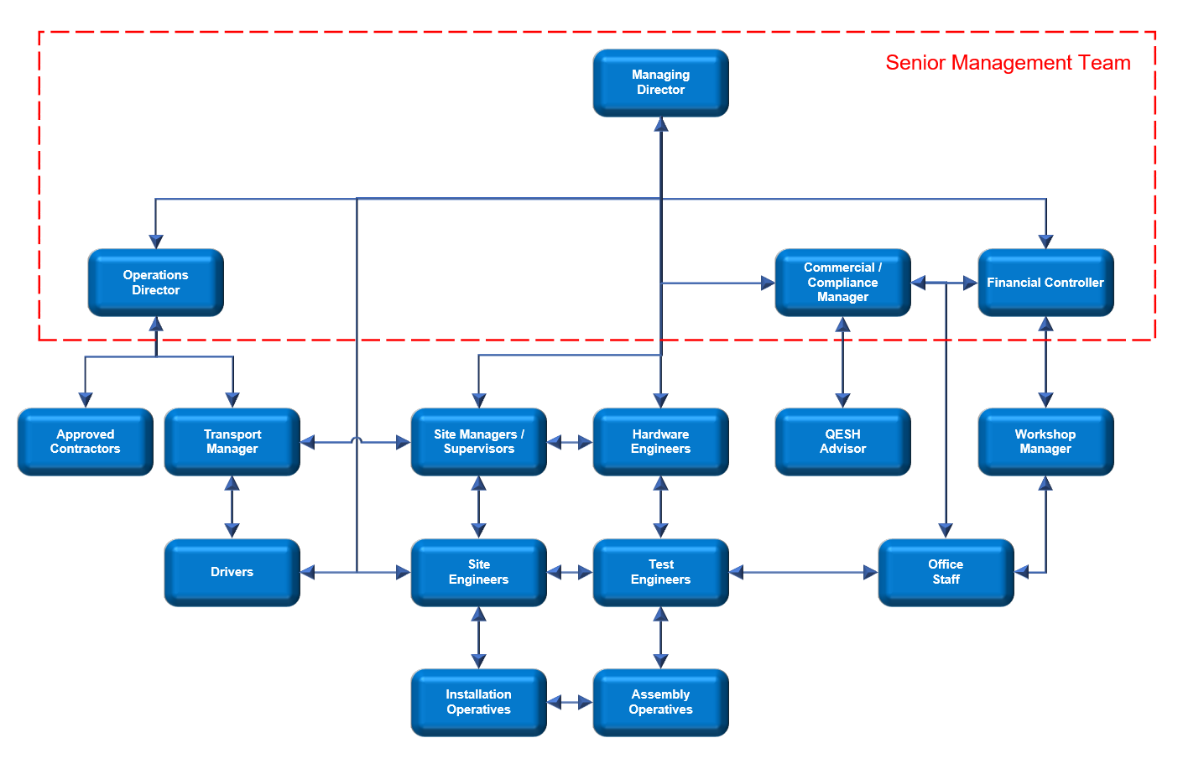

# **7.1 Project Team Structure**

The structure of the organisation describing the line of command and the Manager responsible for the project is as follows.

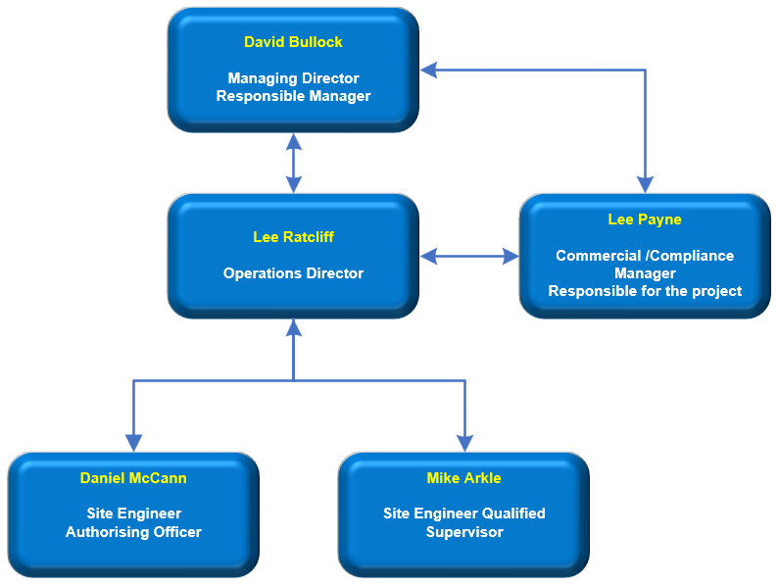

# **7.2** **Project Team Contact Details**

|  |  |  |  |
| --- | --- | --- | --- |
| **Name** | **Function** | **Telephone** | **Email** |
| David Bullock | Managing Director - Responsible Manager |  |  |
| Lee Payne | Commercial / Compliance Manager - Responsible for the project. | 01642 970046 | [lpayne@infratec-uk.com](mailto:lpayne@infratec-uk.com) |
| Lee Ratcliff | Operations Director |  |  |
| Daniel McCann | Site Engineer - Authorising Officer |  |  |
| Mike Arkle | Site Engineer - Qualified Supervisor |  |  |
| **Client Contact** | **Function** | **Telephone** | **Email** |
|  |  |  |  |
|  |  |  |  |
|  |  |  |  |
|  |  |  |  |

# **7.3 Organisational Responsibilities**

**Managing Director**

Maintain the highest level of engineering excellence in hardware and software design.

Technical support when required during the project.

Support the overall delivery of the project objectives.

Administration and record keeping of Technical Queries [TQ].

Promotes the highest standard of quality, environmental and health and safety performance.

**Commercial / Compliance Manager**

Is the Manager responsible for the contracted work and establishing the project team.

Provide a single point of contact for Highways England [HE] Area Team staff for individual Task Orders / installation activities.

The control of team selection including special requirements for skilled personnel e.g. ensuring the training of site staff.

Ensuring the implementation and effective communication with all project stakeholders.

Ensure all company internal procedures and processes are maintained.

Report any non-conformances to the Senior Management Team and Site Engineers and ensure effective close out action.

Ensure all required documentation [Risk Assessments / Method Statements [RAMS] and other documents] are produced in a timely manner and are distributed and communicated to all INFRETEC employees and stakeholders.

Promote and support collaborative behaviours at all times.

Ensuring the project is delivered within the agreed timescale.

Promotes the highest standard of health, safety, environmental and quality performance.

**Operations Director**

Overall responsibility for all processes in the assembly, test and stores areas.

Management of the manufacturing schedule and progress reports to the Managing Director.

Generation of works order operation sheet detailing the required manufacturing process steps.

The release of bills of materials and the correct revision engineering drawings to production.

The procurement of required products to agreed designs and specifications.

Manage supplier issues in a timely manner and the communication of issues to Site Engineers[s].

Promotes the highest standard of health, safety, environmental and quality performance.

**Transport Manager**

The on-time supplier delivery of all required products and / or services.

Promotes the highest standard of health, safety, environmental and quality performance.

**Test Engineers**

To ensure all product testing in completed in line with the company test procedures and against relevant Standards.

Maintain records of all completed tests and make these records readily available for review.

To ensure all products returned for repair are repaired in line with the company test procedures and against relevant Standards.

Repair and log any faults found during the test process.

Promote the highest standard of health, safety, environmental and quality performance.

**Site Engineers**

The safe collection, transportation, installation and commissioning of equipment on site.

Ensuring that site installation and commissioning operatives are scheduled to attend site on agreed dates and hold the correct registration for the NHSS8 sector scheme.

Complete all necessary Risk Assessments and Method Statements prior to installation and commissioning and send to Project Manager[s] for review and approval.

Ensure all site work is completed in line with the agreed method statements and with all risks identified and managed.

Promote the highest standard of health, safety, environmental and quality performance.

**QESH Advisor**

The external consultant provides competent advice and guidance to the businesses on quality, environmental safety & health issues.

Promotes the highest standard of health, safety, environmental and quality performance.

**Competent Persons**

It is the Company's policy that all personnel shall have the necessary skills, competency and experience for the tasks for which they are responsible shall be trained & qualified for the position that they hold within the Company. This will be based upon appropriate education, training, skills and experience.

# **8 INFRATEC Documented Quality Management System.**

INFRATEC-UK have implemented and maintain an Integrated Management System consolidating the common requirements of ISO 9001:2015 Quality Management Systems, ISO 45001:2018 Occupational Health & Safety Management Systems. ISO 14001:2015 Environmental Management Systems and National Highway Sector Scheme 8. The relevant parts of the INFRATEC-UK documented quality management system relevant to the product or service being provided can be identified in INFRATEC-UK Integrated Management System Manual [IMSM 1.0].

# 8.1 Contract Review

The Senior Management Team [SMT] will carry out a detailed review of the entire general contract to ensure that there is a complete understanding of all contractual terms and conditions prior to taking ownership of them.

An order inception review is held internally to instigate the project process with involvement from all internal interested parties and recorded on [IMD018 Order Inception Review Form]. The Commercial Manager will carry out a detailed review of the scheme specific requirements from each Task Order raised under the project to ensure that there is a complete understanding of the scheme requirements prior to taking ownership of them. A Task Order inception review is held internally to instigate site installation planning process including manufacturing activities to ensure that the client delivery dates are achieved.

# 8.2 Documentation

The documents used for the contract/project are authorised for issue, distributed and are subject to document control.

# 8.3 Control of Records

Records created or received will be maintained to provide evidence of conformity to requirements and of the effectiveness of the operation of the quality management system. Records are retained for the design life of the product.

# 8.4 Client Reporting and Communication

Communication between INFRATEC-UK and the client will be led by The Senior Management Team on behalf of INFRATEC-UK and the client contact for the project <**TITLE OF PROJECT >**.

General reporting and communications, such as progress reports and updated timing plans are generally submitted to the customer via direct Email or at scheduled progress meetings as required. [IMD 033 General Communications Form GC] may be used if requested by the Client.

The Client will be informed immediately of any health, safety, environmental or quality issues relevant to the project.

# 8.5 Management of Change

The Senior Management Team [SMT] are responsible for the management of changes to the project once it has commenced and also for the successful communication of such changes to interested parties.

Change control is a formal process used to ensure that a product, service or process is only modified in line with the identified change. All changes are controlled in accordance with the requirements of INFRATEC-UK Integrated Management System Manual [IMSM 1.0] Section 6.3 Planning of Changes.

# 8.6 Control of non-conformities [Concessions and Specification Queries]

Non-conforming components, materials or work will not be used unless written approval has been received from the Client. Any components, materials or work not conforming to the contract specification will either be reworked to conform to the specification or formally accepted in writing by the client. INFRATEC will utilise [IMD 024 Concession/Change Request Form] as formal acceptance under concession in writing from the Client.

All personnel who identify non-conforming products or services supplied by INFRATEC are responsible for reporting their findings on [IMD 031 Corrective Action Request Form (CAR)] so the appropriate course of action can be taken to resolve

When clarification of the client’s requirements is needed or required, a technical query [TQ] will be raised on [IMD032 Technical Query Form] and issued to the customer. All TQs raised will be logged in the project file [IMD028 Project Work File] with an assigned unique identification number, the date it was raised, the originator of the TQ and the date of the customer response.

**8** INFRATEC documented Quality management system.

## 8.7 Control of Processes

The company processes are monitored and checked for effectiveness through the internal programme. The Senior Management Team [SMT] and The Compliance Manager have the authority to request or undertake unscheduled audits of the project quality arrangements at any time during the project lifecycle.

## 8.8 Identification and Traceability

All INFRATEC products have a unique serial number and are used on the work order operations sheet. All the serial numbers of parts used on the finished product are recorded within the build procedures. These numbers are logged on the computer system. The serial number includes a date reference which can easily be recognised when quoted by our customers.

## 8.9 Calibration of Test Equipment

All measuring instruments used for qualified results will be calibrated on a regular basis. Calibration certificates will be held by the Compliance Manager.

## 8.10 Repairing of Product

Unless otherwise agreed, any product requiring repair must be returned to INFRATEC’s premises. The unit will either be repaired free of charge if under warranty, or a quote will be produced if out of warranty.

Any non-conforming product that is reworked will be repaired in a manner that is consistent with accepted standards.

The actions taken to repair the part will be recorded.

## 8.11 Audits

Audits will be performed as per [IMD 025 HSEQ Internal Audit Schedule] to ensure that processes are effective and being followed. Internal and 3rd party Audit reports are reviewed at the time by the Compliance Manager and by The Senior Management at least annually at Management Review meetings for adequacy and to ensure effectiveness.

## 8.12 Purchasing & Supplier Approval

INFRATEC’s integrated management system enables the planning and control of purchasing tasks. Orders can then be raised on the system which require authorisation by the Commercial Manager prior to being sent to the supplier.

Suppliers are reviewed on an annual frequency.

## 8.13 Key Suppliers and Sub-contractors

|  |  |  |  |  |  |
| --- | --- | --- | --- | --- | --- |
| **No** | **Supplier** | **Function** | **ISO 9001** | **ISO 45001** | **ISO 14001** |
| 1 |  |  | ✓ |  |  |
| 2 |  |  | ✓ |  |  |
| 3 |  |  | ✓ | ✓ | ✓ |
| 4 |  |  | ✓ | ✓ | ✓ |
| 5 |  |  | ✓ |  |  |
| 6 |  |  |  |  |  |
| 7 |  |  |  |  |  |
| 8 |  |  |  |  |  |

# 8.14 Handling, Storage, Packaging, Preservation and Delivery

INFRATEC products have been environmentally proven and therefore don’t require any special packaging protection arrangements. All finished products are stored in a secure manner to avoid damage. As transportation of the finished products involves lifting using mechanical assistance, a risk assessment and method statement will be complete to determine adequate control measures. Where appropriate a documented lifting plan will be complete.

# 8.15 Training

Departmental Managers will ensure that personnel assigned to the project have the necessary experience, training and qualifications to perform their intended function and any specific requirements of this contract. Competency reviews are held annually for all employees with competency being assessed as part of the planned internal audit programme.

# 9 Product Verification and Validation

Validation of product is undertaken to ensure that INFRATEC products meet all specifications and requirements.

This is achieved by undertaking the planned arrangements. Part of the Planned Arrangements are inspections and tests to prove that the functionality of the product meets the customer’s requirements in accordance with the requirements. All products complete both a Factory Acceptance Test and a Site Acceptance Test.

# 9.1 Planned Arrangements at INFRATEC Site Operations

The following table explains the Planned Arrangements for meeting all manufacturing requirements. To ensure that the planned arrangements are carried out the following actions are undertaken: - At the completion of each stage it is signed by the operative undertaking the stage. On completion, the Works Order sheet is filed as a quality record.

|  |  |  |  |  |
| --- | --- | --- | --- | --- |
| **Process Name** | **Inputs: Works Instructions/ Drawing** | **Outputs: Product Conformity** | **Departmental Responsibility** | **Comments** |
| Goods Receiving | Purchase Order [PO] | Despatch Note CofC | Stores | Goods not to be booked in until Despatch note & CofC details have been verified. |
| Inspection | PO  Drawings | Delivery note signed. | Inspection/Test | Pass to stores if conforming.  Reject if non-conforming |
| Kitting | Picking list | List marked as issued | Assembly | The parts received are marshalled into a kit and placed in a kitting area in production |
| Assembly | Drawings & Picking list | List signed by assembly | Assembly | Picking list is signed by Assembly to show that the unit is built to the required standard |
| Product validation tests | Test procedure | Results sheet | Assembly/Test | Signed by Assembly/test when unit passes test to the required standard |
| Final Inspection | Drawings & Picking list | Picking list signed by Test personnel | Inspection/Test | Review of picking list to verify all activities are completed and signed accordingly |
| Factory Acceptance Test | FAT Document | FAT Results sheet | Inspection/Test | If Contract or Product specific requirement |
| Despatch Goods | Despatch instructions | Delivery note | Transport | Stores verify goods on S/O, goods packed and delivery note produced. |

# 9.2 Planned Arrangements for On-Site Installation Operations

The following table explains the planned arrangements for meeting all On-Site Client installation, operation and service requirements. To ensure that the planned arrangements are carried out the following actions are undertaken.

On completion the installation records are filed as a quality record.

|  |  |  |  |
| --- | --- | --- | --- |
| **Process Name** | **Inputs/Outputs** | **Departmental Responsibility** | **Comments** |
| Allocation of resource | Planning work / Site Survey | Installation | Only appropriately qualified & trained staff used for works |
| Development of RAMS | Site survey report / RAMS | Installation / Compliance | Installation & Compliance Manager to ensure RAMS are suitable for works |
| Site Operations | Site survey report & RAMS | Installation / Service | Issuing of the appropriate documents is the responsibility of Compliance Manager |
| Pre-installation checks | Sales order requirements / kit of parts | Installation / Service | Ensure the kit is correct by checking against customer requirement |
| Site Installation | Job document pack / Installation complete | Installation / Service | Installation completed using the specific job document pack |
| Visit reports | Site Visit Reports | Installation / Service | The Site Installation & visit report is completed and retained as a quality record |
| Site Acceptance Test | SAT results sheet | Installation / Service | Contract/product specific requirement |

# 10 Health, Safety and Environmental

Health, Safety and the protection of the environment in which we work are of primary importance to INFRATEC.

The Company is committed to reducing its risk profile by implementing control measures and processes to protect the health and safety of our employees, contractors or visitors and to maintain sustainable business practices by reducing our environmental impact.

INFRATEC’s Integrated Management System is accredited by BSI to ISO 45001:2018 and ISO 14001:2015. BSI are a UKAS approved certification body.

## 10.1 Project EHS Objectives

To Ensure hazards and risks are identified, effectively managed and reduced through a robust risk assessment process

All INFRATEC employees working on this project will have the necessary skills, competency and experience for the tasks for which they are responsible.

If Personal Protective Equipment is recommended as part of the risk assessment and safe system of working process it will be worn with no exceptions. Failure to comply with any mandatory PPE requirements can result in disciplinary action.

All site operatives are registered as part of the NHSS8 sector scheme and have completed the applicable training related to the individual’s registration level.

All INFRATEC’s waste streams have been identified and waste will be disposed of responsibly using only licensed waste carriers.

# Contract Specific Activities

| **Client:** | |  | | **Description:** |  | | **QP Number:** | **QP 001** |
| --- | --- | --- | --- | --- | --- | --- | --- | --- |
| **Contract Number:** | |  | | **Project:** |  | | | |
| **Project Manager:** | |  | | **Client Contact:** |  | | | |
| **Item** | **Activity Type** | **Process Stage or Activity** | **Work Instruction, Procedure or Specification** | **Quality Characteristic to be Controlled** | | **Responsibility** | **Verification Record** | **Confirm Process Completed**  **(Sign/Date)** |
|  |  |  |  |  | |  |  |  |
|  |  |  |  |  | |  |  |  |
|  |  |  |  |  | |  |  |  |
|  |  |  |  |  | |  |  |  |
|  |  |  |  |  | |  |  |  |
|  |  |  |  |  | |  |  |  |
|  |  |  |  |  | |  |  |  |
|  |  |  |  |  | |  |  |  |
|  |  |  |  |  | |  |  |  |
|  |  |  |  |  | |  |  |  |
| **11** |  |  |  |  | |  |  |  |